Project 6 Report - Sorting Algorithms

Bradley Trowbridge

COP 3530

Data Structures and Algorithms

Test cases 1000 & 10000:

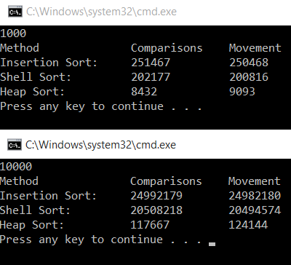

Discussion:

A discussion of the time complexity of each sorting algorithm in terms of Big O

notation.

Write a program to implement and test the following sorting algorithms to sort an array:

1. Insertion sort.

Insertion sort has an average case of O( n^2) because it has to iterate through the list for every element in the list.

1. Shell sort

Shell sort has a time complexity that ranges from O(n log(n)) to O (n^2) because it uses a divide and conquer method which at worst case, must iterate through every element.

1. Heapsort

Heap sort has a time complexity has a complexity of O(n log (n)) because it iterates through each item once (n) by using a binary tree(log n). Thus giving it a time complexity of O(n log n).

A discussion of the memory efficiency.

Each method does not expand on memory based on the size of the list which gives a memory complexity of O(1) since there is no dependency.